Question

you are giving a login page to an online services your task to validate page work whether the form works correctly.
are given a login page to an online service. Your task is to validate
Write a list of test cases that should check whether the given page
works correctly. Write them as JUnit test methods (@Test) in
own WebDriver.
Solution class. Before each test, your class is called with the
WebDriver already pointing at the page being tested. Do not create your
You can play with the fully working reference page here.
You can use the following credentials to check the login process:
- Valid credentials: email: login@codility.com, Password:
password
- Invalid credentials: email: unknown@codility.com,
Password: passwordRequirements:
1. Check if the email and password fields are on the main
screen of the application:
Email input has id equal to email-input;
Password input has id equal to password-input;
Login button has id equal to login-button.
2. Check if the given valid credentials work:
(login@codility.com).
• Use credentials given in the description
• After a successful login attempt, a div with class equal
to message success and containing a message:
Welcome to Codility is visible.
3. Check if the given wrong credentials work:
• Use credentials given in the description
(unknown@codility.com).
• After an unsuccessful login attempt, a div with class
equal to message error and containing a message
You shall not pass! Arr! is visible.
4. Check if the email validation is working:
• Use email in an invalid form
• After an unsuccessful login attempt, a div with class
equal to validation error and containing a message
Enter a valid email is visible.
5. Check for empty credentials:
• After an unsuccessful login attempt, a div with class
al to validation error and containing a message
ired is visible. 3. Check if the given wrong credentials work:
(unknown@codility.com).
• Use credentials given in the description
Join conversation
• After an unsuccessful login attempt, a div with class
You shall not pass! Arr! is visible.
equal to message error and containing a message
4. Check if the email validation is working:
• Use email in an invalid form
• After an unsuccessful login attempt, a div with class
Enter a valid email is visible.
equal to validation error and containing a message
5. Check for empty credentials:
• After an unsuccessful login attempt, a div with class
equal to validation error and containing a message
Email is required is visible.
• After an unsuccessful login attempt, a div with class
equal to validation error and containing a message
Password is required is visible.
Assessment/Tools:
* The WebDriver that is provided (webDriver) in the constructor is
already pointing to the page being tested. * Make sure you annotate
your test cases with a @Test decorator. *If the page being tested is
misbehaving, at least one of your tests should fail.* Performance is not
assessed; focus only on the correctness of the tests. * Tests may take a
longer time than expected due to the browser running in the
background.
You can use the provided page for the reference. Do not point the
WebDriver to this page.
Copyright 2009-2023 by Codility Limited. All Rights Reserved. Unauthorized copying,
uhlication or disclosure prohibited.

Answer

com.coimport org.junit.AfterClass;
org.jimport org.junit.BeforeClass;
import org.openqa.selenium.By;
import org.openqa.selenium.WebElement;
import com.codility.selenium.tests.WebDriverTestCase;
public class Solution extends WebDriverTestCase {
public void testLoginFormPresent() {
webDriver.findElement(By.id("password-input"));
}
public void testvalidcredentals() {
webDriver.findElement(By.id("password-input")).sendKeys("password");
WebElement successMessage = webDriver.findElement(By.xpath("//div[@class=\"message success\"]"));
}
public void testinvalidcredentals() {
webDriver.findElement(By.id("password-input")).sendKeys("password");
WebElement errorMessage = webDriver.findElement(By.xpath("//div[@class=\"message error\"]"));
}
@Test
EmailICredenindEro webDriver.findElement(By.id("email-input")).sendKeys("unknowncodility.com");;
webDriverent(By.id"put")).sende("awod webDriver.findElement(By.id("login-button")).click();
Assert.assertNotNull(errorMessage);
@Test
EmptyCialsAnEMessg webDriver.findElement(By.id("email-input")).clear();
webDriverent(By.id"aut")).clea( webDriver.findElement(By.id("login-button")).click();
WebElement errorMessage1 = webDriver.findElement(By.xpath("//*[@id=\"messages\"]/div[2]"));
Assert.assertNotNull(errorMessage1);
}package com.codility.selenium.candidate;
import org.junit.Assert;
import org.junit.Test;
import org.openqa.selenium.By;
import org.openqa.selenium.WebDriver;
import org.openqa.selenium.WebElement;
import com.codility.selenium.tests.WebDriverTestCase;

public class Solution extends WebDriverTestCase {
@Test
public void testEmailAndPasswordFields() {
webDriver.findElement(By.id("email-input"));
webDriver.findElement(By.id("password-input"));
webDriver.findElement(By.id("login-button"));
}
@Test
public void testvalidcredentialsLogins() {
webDriver.findElement(By.id("email-input")).sendKeys("login@codility.com");
webDriver.findElement(By.id("password-input")).sendKeys("password");
webDriver.findElement(By.id("login-button")).click();
WebElement successMessage = webDriver.findElement(By.xpath("//div[@class=\"message success\"]"));
Assert.assertNotNull(successMessage);
}
@Test
public void testwrongcredentialsgiven() {
webDriver.findElement(By.id("email-input")).sendKeys("unkown@codility.com");
webDriver.findElement(By.id("password-input")).sendKeys("password");
webDriver.findElement(By.id("login-button")).click();
WebElement errorMessage = webDriver.findElement(By.xpath("//div[@class=\"message error\"]"));
Assert.assertNotNull(errorMessage);
}

@Test
public void testEmailValidationisworking() {
webDriver.findElement(By.id("email-input")).sendKeys("unknowncodility.com");;
webDriver.findElement(By.id("password-input")).sendKeys("password");
webDriver.findElement(By.id("login-button")).click();
WebElement errorMessage = webDriver.findElement(By.xpath("//div[@class=\"validation error\"]"));
Assert.assertNotNull(errorMessage);
}
@Test
public void testEmptyCredentials() {
webDriver.findElement(By.id("email-input")).clear();
webDriver.findElement(By.id("password-input")).clear();
webDriver.findElement(By.id("login-button")).click();
WebElement errorMessage = webDriver.findElement(By.xpath("//*[@id=\"messages\"]/div[1]"));
WebElement errorMessage1 = webDriver.findElement(By.xpath("//*[@id=\"messages\"]/div[2]"));
Assert.assertNotNull(errorMessage);
Assert.assertNotNull(errorMessage1);
}
}

Above code successfully compiled

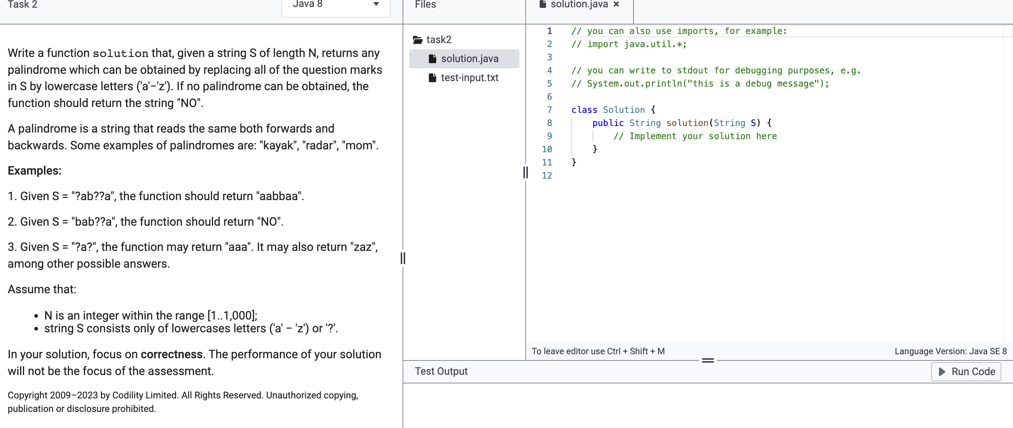

public String solution(String S) {
int n = chars.length;
// Iterate over the characters from both ends
// If both characters are question marks, replace them with 'a'
chars[i] = 'a';
}
else if (chars[i] == '?' && chars[j] != '?') {
}
else if (chars[i] != '?' && chars[j] == '?') {
}
else if (chars[i] != '?' && chars[j] != '?' && chars[i] != chars[j]) {
}

}

import java.util.*;
class Solution {
public String solution(String S) {
char[] chars = S.toCharArray();
int n = chars.length;
for (int i = 0, j = n - 1; i <= j; i++, j--) {
if (chars[i] == '?' && chars[j] == '?') {
chars[i] = 'a';
chars[j] = 'a';
}
else if (chars[i] == '?' && chars[j] != '?') {
chars[i] = chars[j];
}
else if (chars[i] != '?' && chars[j] == '?') {
chars[j] = chars[i];
}
else if (chars[i] != '?' && chars[j] != '?' && chars[i] != chars[j]) {
return "NO";
}
}

return new String(chars);
}
}

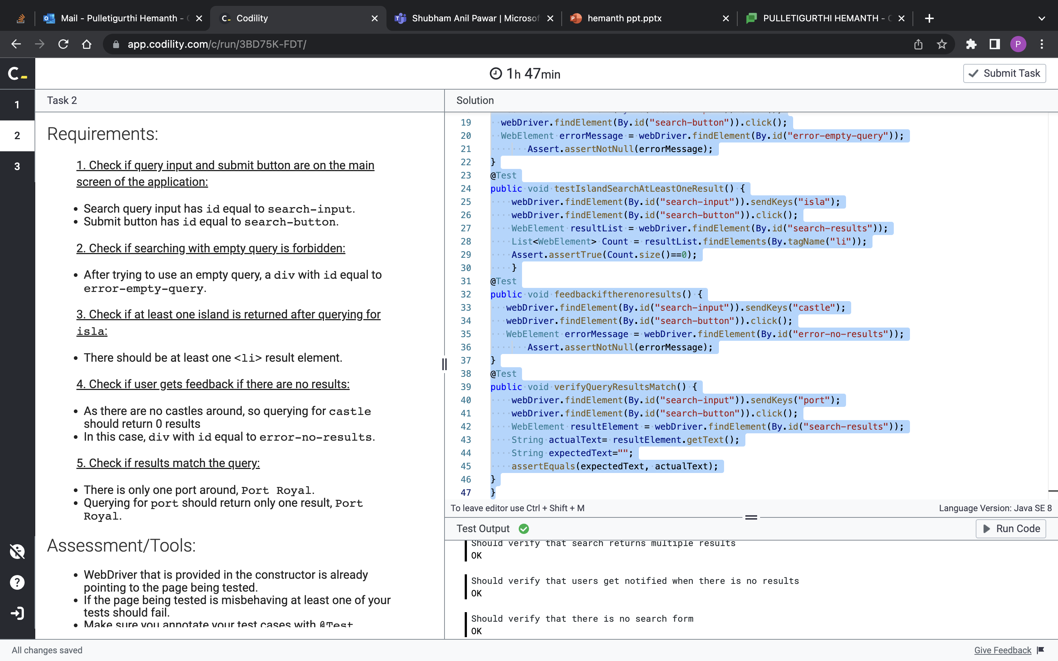
Caption

package com.codility.selenium.candidate;
import org.junit.Assert;
import static org.junit.Assert.assertEquals;
import org.junit.Test;
import java.util.List;
import org.openqa.selenium.By;
import org.openqa.selenium.WebDriver;
import org.openqa.selenium.WebElement;
import com.codility.selenium.tests.WebDriverTestCase;
public class Solution extends WebDriverTestCase {
@Test
public void verifyQueryInputAndSubmitButton() {
webDriver.findElement(By.id("search-input"));
webDriver.findElement(By.id("search-button"));
}
@Test
public void verifyEmptyQueryError() {
webDriver.findElement(By.id("search-input")).clear();
webDriver.findElement(By.id("search-button")).click();
WebElement errorMessage = webDriver.findElement(By.id("error-empty-query"));
Assert.assertNotNull(errorMessage);
}
@Test
public void verifyIslandResults() {
webDriver.findElement(By.id("search-input")).sendKeys("isla");
webDriver.findElement(By.id("search-button")).click();
WebElement resultList = webDriver.findElement(By.id("search-results"));
List<WebElement> Count = resultList.findElements(By.tagName("li"));
Assert.assertTrue(Count.size()==0);
}
@Test
public void verifyNoResultsFeedback() {
webDriver.findElement(By.id("search-input")).sendKeys("castle");
webDriver.findElement(By.id("search-button")).click();
WebElement errorMessage = webDriver.findElement(By.id("error-no-results"));
Assert.assertNotNull(errorMessage);
}
@Test
public void verifyQueryResultsMatch() {
webDriver.findElement(By.id("search-input")).sendKeys("port");
webDriver.findElement(By.id("search-button")).click();
WebElement resultElement = webDriver.findElement(By.id("search-results"));
String actualText= resultElement.getText();
String expectedText="";
assertEquals(expectedText, actualText);
}
}

Above code compile successfully

